Multiple Product Registration Form

Airpod Air Mattress

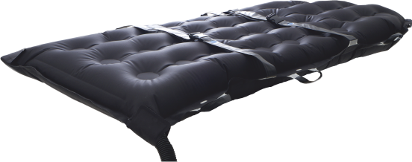

Thank you very much for your purchase. We appreciate your custom.
Please complete this form to register Multiple Product Purchase (more than 2) of the Airpod Air Blower.
Single Product Registration can be completed directly from the Website – please follow the link below:
https://www.rexyn.co/english-language-quick-links-page/ql7-product-registration-and-warranty/ql7a-product-registration/

Facility Information

Section 1 - Customer Details
Date of Purchase
Name of Institution / Trust / Hospital
Number of Units Purchased  (If more than 1 size purchased, complete separate forms for each size) | Units | Size | Standard  Bariatric
Address |  | Postcode
Procurement Team Representative
Telephone number
Email address

Section 2 – Rexyn Dealer Details
Name of Dealer Organisation
Dealer Representative Details  (if known) | Name: | Email:

Product Listing
Section 3 – Product Listing and Unique Serial Numbers
The Product uSN can be found on the Packing List, on the Carton and the Product
ITEM Number | uSN
1
2
3
4
5
6
7
8
9
10
11
12
13
14

